W-20
YEAR 10 SCIENCE (ADJUSTED)
BIOLOGICAL SCIENCES
TEST - GENETICS

NAME: MARK: $\frac{}{\text{57}}$

SECTION A: MULTIPLE CHOICE

Select the best answer for each question below. Write your selection in the box to the right.

MULTIPLE CHOICE ANSWERS
1
2
3
4
5
6
7
8
9
10
11
12
1. The chemical compound that contains the coded instructions for the way that cells develop is:

(a) an amino acid.
(b) DNA.
(c) glucose.
(d) HCl.

2. DNA is found in the:

(a) cell membrane.
(b) endoplasmic reticulum.
(c) nucleus.
(d) cytoplasm.

3. When cells are about to divide, lengths of DNA shorten and coil to form:

(a) chromosomes.
(b) genes.
(c) messenger RNA.
(d) zygotes.

4. The process of cell division that produces sperm and egg cells is:

(a) cloning.
(b) fertilisation.
(c) meiosis.
(d) mitosis.

5. If a woman has already given birth to four boys, the chance that she will have a girl next time is:

(a) zero.
(b) one in five.
(c) one in four.
(d) one in two.
(e) 100%.

6. Three different cells contain one of each of the following sets of genes.

AA Aa aa

Which set of genes represents homozygous (pure-breeding) strains?

(a) AA
(b) Aa
(c) aa
(d) AA and aa.

7. Major differences between males and females are determined by pairs of sex chromosomes.
For example, Jane is a girl and Jim is a boy, because in each cell nucleus:

(a) Jane has two X chromosomes; Jim has two Y chromosomes.
(b) Jane has two Y chromosomes; Jim has two X chromosomes.
(c) Jane has an X and Y chromosome; Jim has two X chromosomes.
(d) Jane has two X chromosomes, Jim has an X and Y chromosome.

8. The following pedigree shows the occurrence of colour blindness in three generations of a
family.

From the above family tree, it can be concluded:

(a) B1 has normal vision.
(b) A2 has colour blindness.
(c) C3 is colour blind.
(d) C1 has normal vision.

9. In a normal body cell of a dogfish shark there are 24 chromosomes.
How many chromosomes are found in each of its reproductive cells?

(a) 24
(b) 12
(c) 8
(d) 48

10. The part of the cell which controls cell function is called the:

(a) nucleus.
(b) cell wall.
(c) protoplasm.
(d) vacuole.

11. How many chromosomes do humans have in their normal cells?

(a) 22
(b) 23
(c) 46
(d) 44

12. Tongue rolling is due to the dominant gene R and the inability to roll your tongue is due to the
recessive gene r. Which of the following pairs of parents could produce a non-tongue roller
(rr)? (Hint: You may need to do some punnet squares to work it out.)

(a) RR and RR
(b) RR and Rr
(c) RR and rr
(d) Rr and Rr

SECTION B: SHORT ANSWER

1. Label the following simple cell drawing. (8 marks)

Nucleus Ribosome Mitochondria Rough Endoplasmic Reticulum Golgi Apparatus Nucleolus Cytoplasm Centrioles

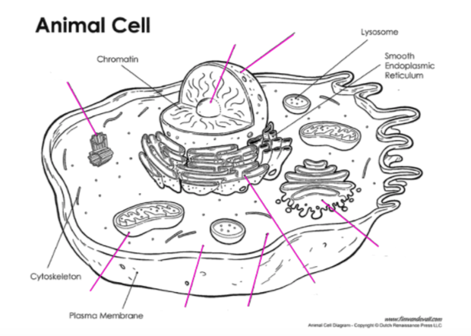

2. (a) Give the 4 letters for the bases in a DNA molecule. (2 marks)

• • • •

(b) Which bases are paired together in DNA? (2 marks)

(c) Draw the adjoining strand of DNA for the following. (2 marks)

- G - T - T - A - C - A - G - T

3. Below is a diagram showing the mitosis cell division process. The stages are in the wrong order. Try to put them in the correct order in the blank diagram. (3 marks)

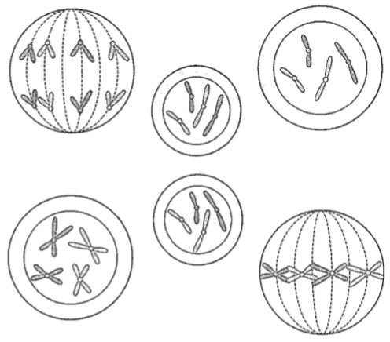
2
5
4
3
1

Write the number in the correct circle in the diagram below.

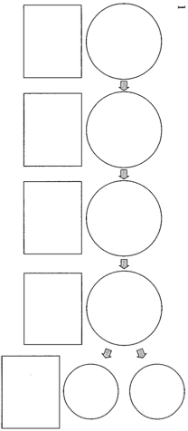

4. In the table below, choose the correct statement for each word given. Write the letter of the correct statement next to the word.
(4)
WORD | CORRECT  LETTER | STATEMENT
hybrid |  | A - how an organism looks due to its genes.
gamete |  | B - hides the other gene in a pair (e.g. T).
dominant |  | C - see a new characteristic in an organism.
incomplete dominance |  | D - same genes in a pair (e.g. TT, tt).
genotype |  | E - gene that is hidden by another gene (e.g. t).
pure-bred |  | F - the genes for a particular characteristic.
recessive |  | G - sex cell of an organism
phenotype |  | H - different genes in a pair (e.g. Tt)

5. In pea plants, the allele for tall height (T) is dominant over the allele for short height (t).

A pure-breeding tall plant (TT) is crossed with a hybrid tall (Tt) plant.
List the possible genotypes and phenotypes of the offspring and show the probability
(percentages) for each offspring. (Set your working out clearly.) (4 marks)

6. The pedigree below shows the occurrence of myopia (short-sightedness) in three generations of a family. It is a recessive trait.
i.e. N = normal-sight, n = short-sighted.

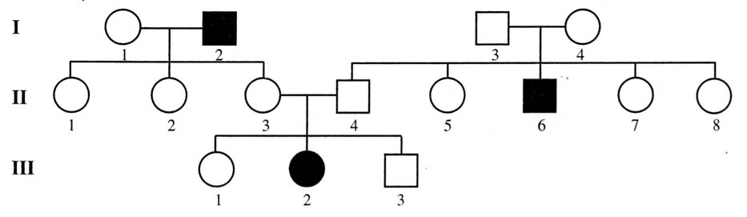

(a) How many males are short-sighted? (1 mark)

(b) How many females are normal-sighted? (1 mark)

(c) How many children did parents II 3 and II 4 have? (1 mark)

(d) How many of their children have normal sight? (1 mark)

(3) Determine the genotypes of the individuals in the pedigree. (Remember to work from
the bottom up.) (3 marks)

